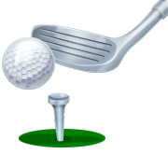
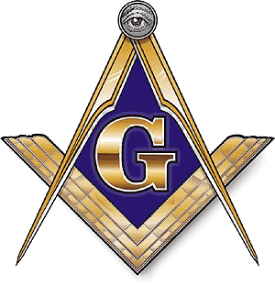
FERNLEY MASONIC LODGE #34 F. & A. M.
RODGER DENN SCHOLARSHIP GOLF TOURNAMENT SPONORS
SEPTEMBER 7, 2024
SIERRIA SAGE GOLF COURSE
10:00 A.M. SHOTGUN START

Please come be a part of our annual fundraiser to help our local kids. Money raised will be used to create scholarships for high school students in our area, to help support the Fernley High School Band, and to support the Shriner Hospital that serves our needy children.
You can help expand the opportunities our kids need to succeed.

SPONSORSHIPS
All sponsors will be recognized at our presentation.

PLATINUM SPONSOR
$1500.00 Donation
Our Platinum Sponsor will receive 4 player entries (also fill out a player’s sheet) that include green fees at the course. Will have recognition at the designated HOLE IN ONE tee box. Will have area to hang banner (provided by sponsor) Sponsors may provide coupons and other promotional items for their business to be included in our golf sponsorship package.

GOLD SPONSOR
$1000.00 Donation
Our Gold sponsors will receive 4 player entries (also fill out a player’s sheet) that include green fees at the course. Tee Sign recognition will be placed on one of our non-target par threes. And recognition of sponsorship.

SILVER SPONSOR
$700.00 Donation
Our Silver Sponsors will receive 4 player entries (also fill out a player’s sheet) that include green fees at the course, and includes Tee sponsor.
Tee Sponsors
$150.00 per hole
Tee signs will be placed on a tee box on the course depicting your name and/or logo (need to be emailed)

Goodie Bags
Items are needed for at least 100 goodie bags. Items requested can promote your business and should be of a size that can be easily placed into a bag. Example: tees, pens, golf balls, coupons, cards etc.

Raffle Prizes
Large items that can be used in drawings and your donation will be acknowledged. Example: golf clubs, shirts, caps, sporting good items, dinner vouchers, gift cards etc.

SPONSOR REGISTRATION FORM
FERNLEY MASONIC LODGE #34 F. & A. M.
RODGER DENN SCHOLERSHIP GOLF TOURNAMENT
SEPTEMBER 7, 2024 SIERRIA SAGE GOLF COURSE
10:00 A.M. SHOTGUN START

PLATINUM GOLD SILVER TEE RAFFLE GOODIE BAG
(PLEASE CIRCLE LEVEL OF SPONSORSHIP)

NAME______________________________________________________

ADDRESS___________________________________________________

PHONE NUMBER_____________________________________________

E-MAIL______________________________________________________

RAFFLE SPONSOR: PRIZE DONATED___________________________

GOODIE BAG SPONSOR: ITEM/S PROVIDED_____________________

OTHER: _____________________________________________

Sponsorships may be modified if requested.

Thank you in advance and we hope you enjoy our event.
We greatly appreciate your continued support.

GOLF CLUB OF FERNLEY located at 50 Desert Lakes Drive, Fernley, NV 89408

Contact: E-Mail Form to FernleyLodge34@outlook.com

Fernley Lodge #34, F. & A. M.
P. O. Box 297, Fernley, NV 89408
Visit website fernleylodge34.org
Email FernleyLodge34@outlook.com

